Psychology 395:
Research Design & Measurement in Psychological Research
Spring 2025
LECTURE Day/Time:
T & R 9:10-10:00AM
LECTURE LOCATION:
Ernst Bessey Hall Rm 108
Instructor: Nathan T. Carter, Ph.D.
Office: 317 Psychology
e-mail: ntcarter@msu.edu
NOTE: Office Hours Requires at Least 24 hours Advance Notice Email to the Instructor
(If no one emails at ntcarter@msu.edu, I am unlikely be available!)
OFFICE HOURS: W 9AM-12PM

REQUIRED TEXT:

Morling, B. (2021). Research Methods in Psychology (4th Ed). Norton. (NOTE: You can use the 3rd and 2nd Editions as well, but class attendance becomes more important if you do, and neither myself or your TAs are responsible for filling any gaps).

Overview of course:
The primary goal of this course is to familiarize students with both the philosophical and practical considerations of conducting psychological research. Students will learn the basics of designing of experimental and observational studies, data collection and analysis, and reporting.

Learning Objectives: By the end of this course students should be able to: (a) critically evaluate simple research designs and the conclusions drawn from them; (b) interpret and produce simple descriptive and inferential statistics; (c) report simple descriptives and inferential statistics in a manner consistent with APA style guidelines.

Course materials: Class and lab announcements and communication will be conducted using D2L. The D2L website can be found at https://d2l.msu.edu/d2l/loginh/

Computer: We will be using R Studio for data analysis in labs. This is a free software that can be downloaded here: https://posit.co/download/rstudio-desktop/. Note that you must download both R (the “base” program) and R Studio (the interactive part of the program where code is written); you will only need to open R Studio when using the program.

GRADING:
Grades will be based (a) EIGHT (8) TAKE-HOME LAB ASSIGNMENTS; and (b) FOUR (4) ONLINE TAKE-HOME EXAMS

(a) EIGHT TAKE-HOME LAB ASSIGNMENTS: 60% (7.5% Each)
Lab assignments will be assigned that ask you to analyze and/or interpret data using the skills you learn in class and lab. These assignments are intended to help cement the knowledge you have gained into workable skills. Notably, this will familiarize you with R, which is a very in-demand skill in business and academia.

Lab Assignments will be reviewed by the Teaching Assistant (TA) in charge of your section. Prior to the assignment, your TA will review the skills necessary and walk through an example. Afterward, you will be required to complete the assignment and turn them in to your TA. Your TA will let you know how they prefer to receive completed assignments (e.g., email, D2L, etc.). Many of these assignments will be done mostly during lab sessions. The assignment must be completed prior to your next lab meeting.

(b) FOUR TAKE-HOME EXAMS: 40% (15% Each)
Each exam will be 20 multiple-choice questions; I will give you two full days (48 hours) to take the exam but are designed to take less than 50 minutes. The exams will be online and administered through D2L. You will not be required to use R or R Studio during the exam, but some questions may involve interpreting output for statistical analyses.

IMPORTANT POINTS ABOUT EXAMS:
- THERE WILL BE NO LECTURE THE DAY THE SYLLABUS SAYS THERE IS AN EXAM. THIS GIVES YOU CLASS TIME TO WORK ON THIS.

The Final Exam is NOT cumulative. Each exam will consist of material covered after the previous exam. Guaranteed baseline final grade calculation:
90%-100% = 4.0
85%-89% = 3.5
80%-84% = 3.0
75%-79% = 2.5
70%-75% = 2.0
69% or lower = 0.0
Extra Credit:
Please see the part of this document after the schedule. It has information on a study that can be used to gain up to 15 points applied to your letter grade (i.e., you can get up to 115% in the course if you get a perfect score on exams and labs, and participate in all parts of the study).
Miscellaneous MSU Rules/Regulations
Academic Honesty:
The Spartan Code of Honor states, "As a Spartan, I will strive to uphold values of the highest ethical standard. I will practice honesty in my work, foster honesty in my peers, and take pride in knowing that honor is worth more than grades. I will carry these values beyond my time as a student at Michigan State University, continuing the endeavor to build personal integrity in all that I do." In addition, Article 2.III.B.2 of the Student Rights and Responsibilites (SRR) states that "The student shares with the faculty the responsibility for maintaining the integrity of scholarship, grades, and professional standards." The (insert name of unit offering course) adheres to the policies on academic honesty as specified in General Student Regulations 1.0, Protection of Scholarship and Grades; the all-University Policy on Integrity of Scholarship and Grades; and Ordinance 17.00, Examinations. (See Spartan Life: Student Handbook and Resource Guide and/or the MSU Web site: www.msu.edu.)
Therefore, unless authorized by your instructor, you are expected to complete all course assignments, including homework, lab work, quizzes, tests and exams, without assistance from any source. You are expected to develop original work for this course; therefore, you may not submit course work you completed for another course to satisfy the requirements for this course. Also, you are not authorized to use the www.allmsu.com Web site to complete any course work in this course. Students who violate MSU academic integrity rules may receive a penalty grade, including a failing grade on the assignment or in the course. Contact your instructor if you are unsure about the appropriateness of your course work. (See also the Academic Integrity webpage.)
Limits to confidentiality. Essays, journals, and other materials submitted for this class are generally considered confidential pursuant to the University's student record policies. However, students should be aware that University employees, including instructors, may not be able to maintain confidentiality when it conflicts with their responsibility to report certain issues to protect the health and safety of MSU community members and others. As the instructor, I must report the following information to other University offices (including the MSU Police Department) if you share it with me:
--Suspected child abuse/neglect, even if this maltreatment happened when you were a child,
--Allegations of sexual assault or sexual harassment when they involve MSU students, faculty, or staff, and
--Credible threats of harm to oneself or to others.
These reports may trigger contact from a campus official who will want to talk with you about the incident that you have shared. In almost all cases, it will be your decision whether you wish to speak with that individual. If you would like to talk about these events in a more confidential setting you are encouraged to make an appointment with the MSU Counseling Center.
Accommodations for Students with Disabilities (from the Resource Center for Persons with Disabilities (RCPD): Michigan State University is committed to providing equal opportunity for participation in all programs, services and activities. Requests for accommodations by persons with disabilities may be made by contacting the Resource Center for Persons with Disabilities at 517-884-RCPD or on the web at rcpd.msu.edu. Once your eligibility for an accommodation has been determined, you will be issued a Verified Individual Services Accommodation ("VISA") form. Please present this form to me at the start of the term and/or two weeks prior to the accommodation date (test, project, etc.). Requests received after this date may not be honored. IF YOU HAVE AN EXAM TIME ACCOMODATION IT WILL BE HONORED BUT YOU MUST RESEND YOUR VISA WITH YOUR EXAM EACH TIME TO ENSURE YOU HAVE COMPLETED IT IN TIME. (For example if your VISA accommodation gives you twice the amount of time you will have two weeks to complete the take-home exam).
Commercialized Lecture Notes: The Code of Teaching Responsibility requires that students receive the written consent of the instructor to sell or otherwise commercialize class notes and materials. Specifically, the Code of Teaching Responsibility states, “Instructors may allow commercialization by including permission in the course syllabus or other written statement distributed to all students in the class.” The Ad Hoc Committee on Social Media, Pedagogy, Academic Rights and Responsibilities in their final report (January 10, 2014) suggested the following language:
As members of a learning community, students are expected to respect the intellectual property of course instructors. All course materials presented to students are the copyrighted property of the course instructor and are subject to the following conditions of use:
1. Students may record lectures or any other classroom activities and use the recordings only for their own course-related purposes.
2. Students may share the recordings with other students enrolled in the class, provided that they also use the recordings only for their own course-related purposes.
3. Students may not post the recordings or other course materials online or distribute them to anyone not enrolled in the class without the advance written permission of the course instructor and, if applicable, any students whose voice or image is included in the recordings.
4. Any student violating the conditions described above may face academic disciplinary sanctions, including receiving a penalty grade in the course.

Disruptive Behavior: Article 2.III.B.4 of the Student Rights and Responsibilities (SRR) for students at Michigan State University states: "The student's behavior in the classroom shall be conducive to the teaching and learning process for all concerned." Article 2.III.B.10 of the SRR states that "The student and the faculty share the responsibility for maintaining professional relationships based on mutual trust and civility." General Student Regulation 5.02 states: "No student shall . . . interfere with the functions and services of the University (for example, but not limited to, classes . . .) such that the function or service is obstructed or disrupted. Students whose conduct adversely affects the learning environment in this classroom may be subject to disciplinary action.

Religious Accommodations
The faculty and staff must be sensitive to the observance of religious holidays so that students who absent themselves from classes on these days are not disadvantaged in any way. Students who miss class, assignments, or exams to observe a religious holiday must be accommodated in ways that include, but are not limited to, the following:

(1) Professors and instructors should make every effort to avoid scheduling exams and oral presentations during the major holidays of religions on campus (Jewish, Muslim, Hindu, etc.). If a professor has scheduled such an exam or oral presentation, exams must be reasonably rescheduled without academic penalty.

(2) Absences may not be counted as a missed class in any course in which attendance is a measure of academic performance. Some instructors attempt to cover all reasons for student absences from required academic events such as quizzes or exams with a blanket policy, e.g., allowing the student to drop one grade or two quizzes without penalty, or allowing a certain number of “unexcused” absences during a semester. This kind of policy should not be applied to religious observances, as this penalizes religions with more holidays that require absences than others.

(3) Reasonable extensions of time must be given, without academic penalty, for missed assignments; students must be allowed to schedule presentations around such absences. Make-up work should be appropriate and not more difficult than the original assignment.

(4) It is the responsibility of those students who need to be absent to inform their instructor at least two weeks before the holiday, make arrangements in advance with their instructors, and to catch up on any material discussed and assignments given during that class period. Accommodations must never fundamentally alter an essential requirement of the course or academic program.

(5) All faculty must refer to this religious policy in their syllabi as well as provide the deadline in the syllabus by which students need to inform instructors of a conflict. Faculty should remind students of the deadline during the first day of class.

(6) Orientation programs for new students -- including the orientations for international students -- must inform incoming students about this policy and urge them to check for conflicts before the deadline for informing their instructors.

To support implementation of these requirements, the Office of the Provost maintains a Religious Observance Calendar resource webpage to identify major religious observation days. Faculty must consult the calendar when planning their syllabi to make every effort to avoid having major exams or presentations on any of the major religious observation days and be responsive to requests for accommodation related to these observances.

As an institution, our practices must conform to our commitments. We are confident that by working together we can continue to build an environment that acknowledges diversity, fosters inclusion and promotes our shared success.

Emergency Procedures
If an emergency should occur that would require the cancellation of class, I will send an email. While an emergency occurring during class is unlikely, please take time the first day to think through your emergency plans for such events (e.g., know at least two exits from the building). To receive emergency messages, set your cellular phones on silent mode when you enter this classroom. If you observe or receive an emergency alert, immediately and calmly inform your instructor. (See also www.alert.msu.edu)
LECTURE SCHEDULE (FINAL ONE IN PROGRESS)
Note: This schedule is tentative and subject to change. Changes will be noted in class.

LEC | TOPIC | READING | WK | LAB TOPIC
14-Jan | No Class | n/a | 1 | NO LAB
16-Jan | Intro to the Course | Ch. 1
21-Jan | Consuming Research I | Ch. 1 | 2 | NO LAB
23-Jan | Consuming Research II | Ch. 2 & 3
28-Jan | Critically Evaluating Research I | Ch. 3 | 3 | Introductions & Downloading R
30-Jan | Critically Evaluating Research II | Ch. 3
4-Feb | Ethics | Ch. 4 | 4 | Importing/Exporting Data & R Basics
6-Feb | Exam Review
11-Feb | EXAM 1: Consuming &Evaluating Research, & Ethics |  | 5 | NO LAB
13-Feb | NO CLASS
18-Feb | Statistics Review: Descriptive Statistics I | p. 467-489 | 6 | Descriptive Statistics & Basic Graphs
20-Feb | Measurement in Psychological Science I | p. 467-489
25-Feb | Measurement in Psychological Science II | Ch. 5 | 7 | Reliability and Analyzing Survey Data
27-Feb | Analysis of Survey Data & Sampling | Ch. 6 & 7
4-Mar | NO CLASS (Spring Break) |  | 8 | NO LAB
6-Mar | NO CLASS (Spring Break)
11-Mar | Exam Review |  | 9 | NO LAB
13-Mar | EXAM 2: Descriptive Statistics & Measurement
18-Mar | Statistics Review: Inferential Statistics I | p. 499-522 | 10 | Inferential Statistics
20-Mar | Statistics Review: Inferential Statistics II | p. 499-522
25-Mar | Correlational Research I | Ch. 8 | 11 | Correlation & Simple Regression
27-Mar | Correlational Research II | Ch. 8
1-Apr | EXAM 3: Inferential Statistics & Correlational Research |  | 12 | NO LAB
3-Apr | NO CLASS (SIOP Convention)
8-Apr | Correlational Research III | Ch. 8 & 9 | 13 | Advanced Regression
10-Apr | Experimental Research I | Ch. 10
15-Apr | Experimental Research II | Ch. 11 | 14 | t-Test & ANOVA
17-Apr | Experimental Research III | Ch. 12
22-Apr | "Floating Day" (Extra day just in case) |  | 15 | ANOVA & Interactions
24-Apr | Exam Review
25-Apr | EXAM 4: Experimental Research & ANOVA

LAB SCHEDULE
Note: This schedule is tentative and subject to change. Any changes will be noted in class.

SN | Day | Start | End | TA
001 | M | 8:00 | 9:50 | Taylor Martin
002 | M | 4:10 | 6:00 | Rachel Pyram
003 | T | 10:20 | 12:10 | Lindsay Ackerman
004 | T | 4:10 | 6:00 | Lexi LaChappa
005 | W | 8:00 | 9:50 | Taylor Martin
006 | W | 12:40 | 2:30 | Laura Bauer
007 | R | 10:20 | 12:10 | Lindsay Ackerman
008 | R | 4:10 | 6:00 | Lexi LaChappa
009 | M | 10:20 | 12:10 | Rachel Pyram
010 | W | 4:10 | 6:00 | Laura Bauer

MSU Personality Study

You can earn up to 15pt of (extra) credit that will count toward your final letter grade by participating in an online psychology study.

This online study examines people’s personalities over the course of a semester. The study will involve answering a few questions about your personality. You can complete a wave of the study each week during the semester. For each wave that you complete, you will earn 1pt (extra) credit toward your final letter grade. There are 15 total weeks in the semester; so if you complete the study once each week (15 times), you’ll get a total of 15pt (extra) credit.

To make sure you have enough time to complete all 15 waves, you should complete the 1st wave of the study as soon as possible!

Registering an Account
To participate in this study, you will need to first register an account on www.PersonalityAssessor.com. If you already have a Personality Assessor account, you can use your existing account. To register a new account, follow these steps:

- Visit www.PersonalityAssessor.com/register/

- You will need to provide a valid email address. An activation email will be sent to your email address. You will have to activate your account before you can sign in. Make sure to remember your password! You will need it to complete all 15 waves of the study!

Completing the First Wave
The first time you complete the study, you will need to follow these steps:

- If you haven’t already, sign into your Personality Assessor account.

- Visit www.PersonalityAssessor.com/msu-personality/. Note: you must type this address into your internet browser. This study does not appear on Personality Assessor homepage! Typing in this link will ONLY work if you’re signed-in!

- The first time you complete the study, you will need to provide your name and NetID. This information is not linked to your responses, but is used only to give you credit for completing the study.

- Complete the study by answering the questions. Make sure to click the “Finish” button at the end and wait for the results page to appear!

Completing Waves 2-15
To complete subsequent waves of the study, follow these steps.

- Visit www.PersonalityAssessor.com.

- Sign into your account.

- After signing in, the MSU Personality Study will appear in your list of available studies. Simply click on it to complete another wave of the study.
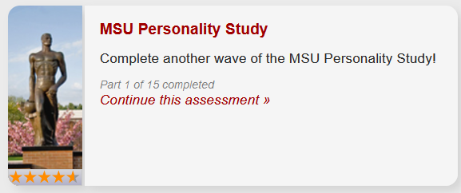

- Please note, you can only complete the study once every 5-6 days. If you try to access the study too early, you will see a message telling you that you have to wait a few more days to complete another wave.
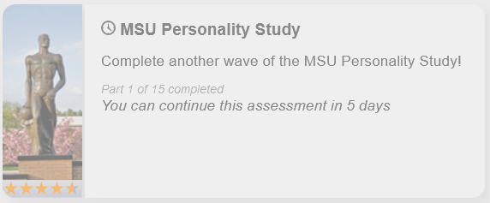

Finishing the Study
The last day to complete the study is the Monday of Finals Week. Once you have completed 15 waves, you will be able to view a results page that shows your personality traits over the course of the semester.

For students who completed 14 or fewer waves, your results page will be made available to you by the end of the Tuesday of Finals Week.

Personality Assessor will automatically send your instructor an email detailing how many times you’ve completed the study at the end of the semester. To see how many waves you have completed, you can always log into your account. The study will list how many parts you have completed.
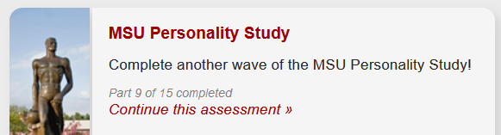
Tips & Hints

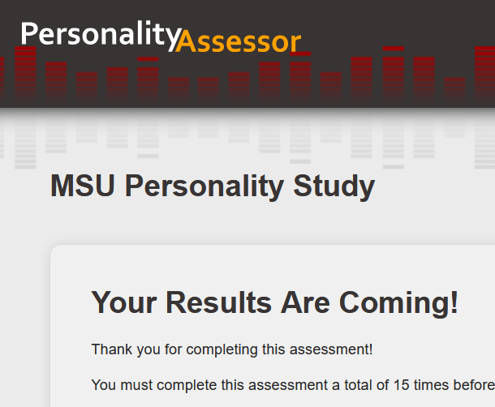
- Always make sure to finish each wave of the study.
Wait for the results page to appear BEFORE closing the internet browser. If you close your internet browser or navigate to a different page before the results page appears, your data might not be saved, and you won’t get credit for completing that wave. If you submit the survey and the website times out (e.g., brings up a page that says “page unavailable” or similar after you clicked the finished button), do not close the tab or leave the page—wait a few minutes and click your browser’s refresh button.

- Email reminders.
Personality Assessor will automatically send you an email reminder each week when you are able to complete the study again. You can easily opt out of these emails using the provided link at the bottom of the email. Opting out by clicking the link in the email is permanent and cannot be undone. (Note: you can also opt out of all communication from Personality Assessor in your account settings. If you do so, you will receive no reminders for the study, or any other email from Personality Assessor. You can always visit your account settings page and opt back into receiving communication from Personality Assessor.)

- Don’t accidentally complete the wrong study.
There are many studies available on Personality Assessor. You will receive credit only for completing the “MSU Personality Study.” None of the other studies are the same as this study, and you will not receive credit for completing them.

